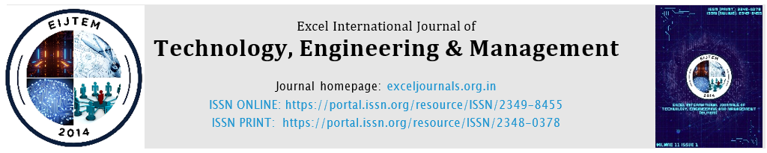

Trebuchet MS size:12
Original article

Enhancing Supply Chain Transparency and Efficiency through Blockchain Technology
Name
School of XYZ, University of XYZ, Place ,India
E-mail address: 20220931109@bucm.edu.cn.

DOI: https://doi.org/10.1016/j.aej.2024.07.057
Received 8 April 2024; Accepted 15 July 2024; Available online 23 July 2024.
Trebuchet MS size:10

Trebuchet MS size:10

Abstract:
Dsljdslkjldsjsdj

Keywords:

Trebuchet MS size:12

Introduction:

Trebuchet MS size:12
Material and methods:

Trebuchet MS size:12
Results:

Trebuchet MS size:12
Discussion:

Trebuchet MS size:12
Conclusions:
Trebuchet MS size:10
Declaration of Competing Interest:
The authors declare that they have no known competing financial interests or personal relationships that could have appeared to influence the work reported in this paper
Trebuchet MS size:10

References
- F. Tian, B. Zheng, R. Zhang, S. Mu, H. Wang, Blockchain-based shared audit service for supply chains, Procedia Comput. Sci. 159 (2019) 305–311.
- M. Wüst, A. Gervais, Do you need a Blockchain? 2018 Crypto Valley Conf. Blockchain Technol. (2018) 45–54.
- S. Kim, A. Laskowski, Toward an evolutionary framework of trust in blockchain-based supply chains, Sustain. 13 (2021) 1–14.
- H. Treiblmaier, B. Röck, E. Kozhakhmetova, The impact of blockchain on e-commerce: A framework for online retailing, J. Retail. Consum. Serv. 52 (2020) 101895.

Note: before pdf generate, pl remove yellow color and all boxes, and this note also

